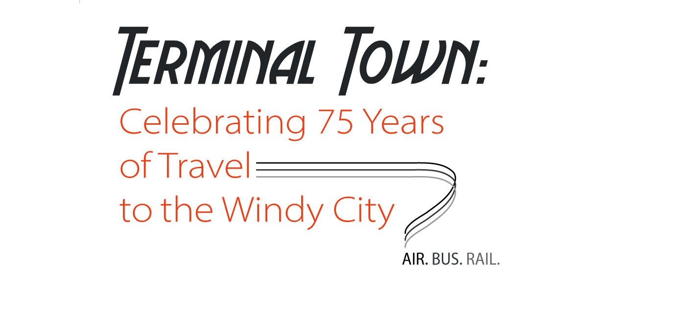
Terminal Town: Celebrating 75 Years
of Travel to the Windy City
Commemorative Banquet and Gala
Maggiano’s Little Italy
516 N Clark St, Chicago, IL
Friday, November 21, 2014
reception: 5:30 p.m. & dinner and program: 6:30 – 8:30 p.m.
To Register: Click Here!

This autumn, DePaul University’s Chaddick Institute for Metropolitan Development will host a festival of programs to build awareness of Chicago’s extraordinary role as a center of U.S. passenger transportation. The program, entitled “Terminal Town: Celebrating 75 Years of Travel to the Windy City,” will feature a wide range of events, a traveling exhibit, and an illustrated book. All are designed to foster understanding of the Chicago region’s remarkable role as America’s premier transportation center and to showcase the exciting possibilities ahead to strengthen its air, bus, and rail systems.
We hope you can join the celebration! The Terminal Town Commemorative Banquet will be held at Maggiano’s Little Italy in Downtown Chicago on the evening of Friday, November 21, 2014 (a week prior to Thanksgiving). The $35 registration fee includes a 3-course dinner, an opportunity to view our traveling exhibit, and a fast-moving program that will feature industry professionals, organizations, and projects that have impacted our region’s transportation terminals.
We expect this event to sell out so reserve your seat now! If you book prior to June 30, we are offering a special early bird price of $30. Please note the fee is refundable through November 1, 2014. Add the all-color Terminal Town book for only $18, a 33% discount.

There are a number of registration options available:

- $30: Early bird price through June 30. (Regular price $35; refundable
through Nov. 1).
- $48: Early bird price + discounted book: Terminal Town: An Illustrated Guide to Chicago's Airports, Bus Depots, Train Stations, and Steamship Landings, 1939 – Present, by Joseph P. Schwieterman (Lake Forest Press, forthcoming, 300 pages).
- $240: Table of eight, early bird price.
- $400: Sponsorship table of eight: includes recognition at the event and in the program. Sponsorship provides support for our awards programs and will allow a DePaul graduate student to attend the event at no cost.

